**NAME : SURAJ SAHANI & JAISHREE SINGH**

**TOPIC : E-COMMERCE WEB APPLICATION**

**TECHNOLOGY USED TO DEVELOP THIS WEBSITE : -**

**1)FRONTEND DEVELOPMENT :- HTML & CSS**

**2)BACKEND DEVELOPMENT :- DJANGO**

**REGISTRATION PAGE :-**

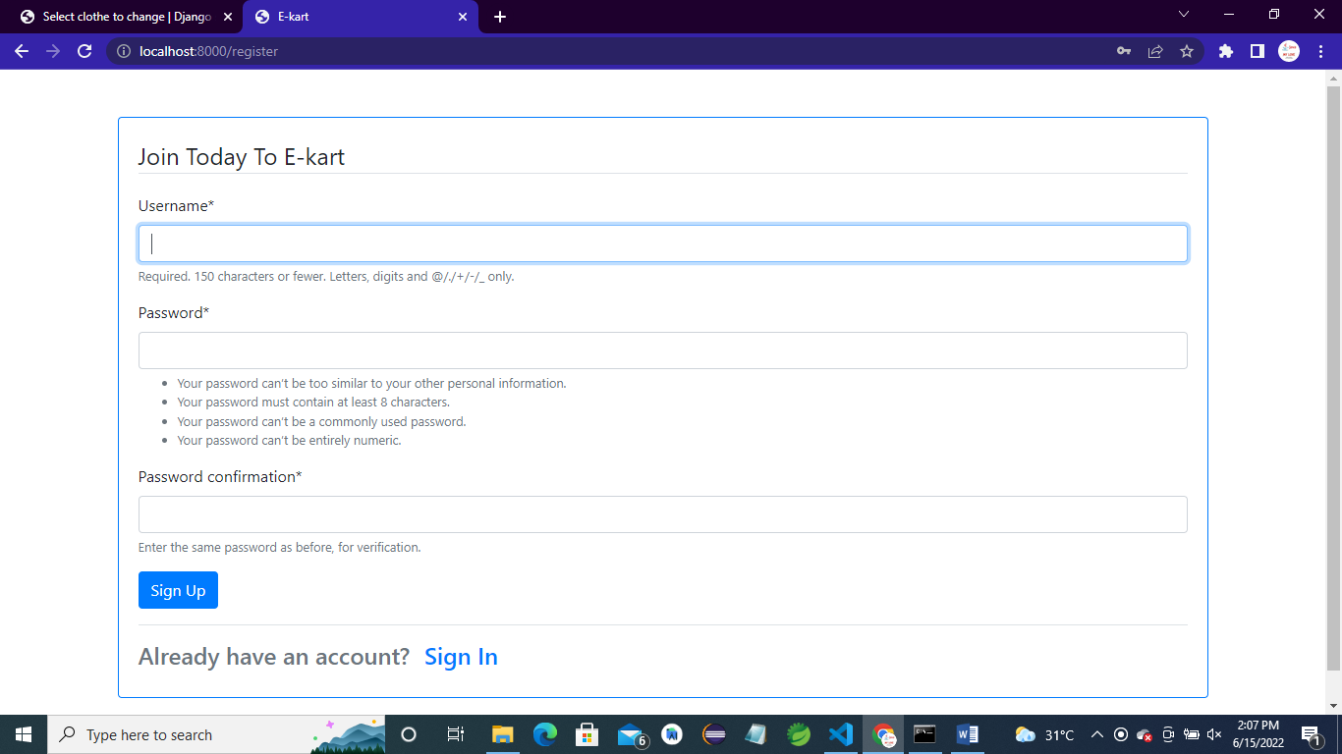

**LOGIN PAGE :-**

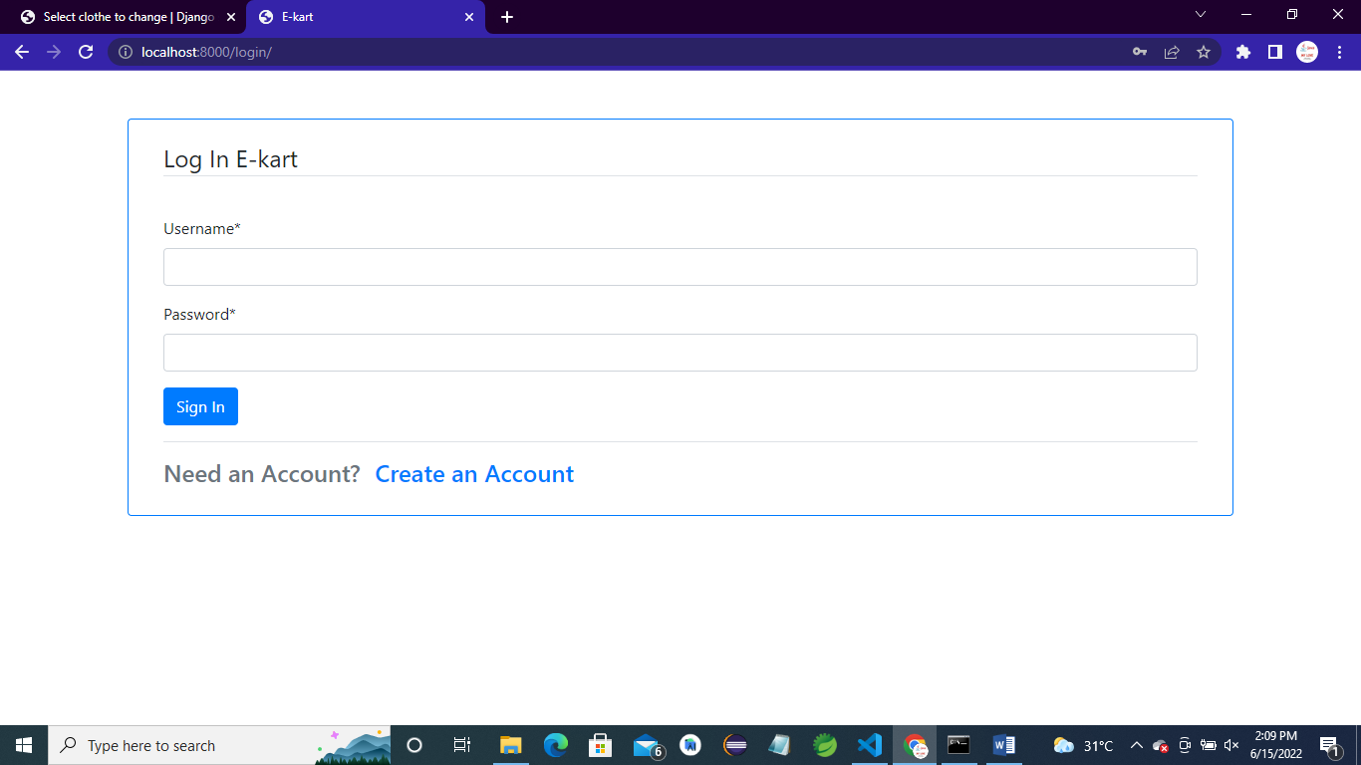

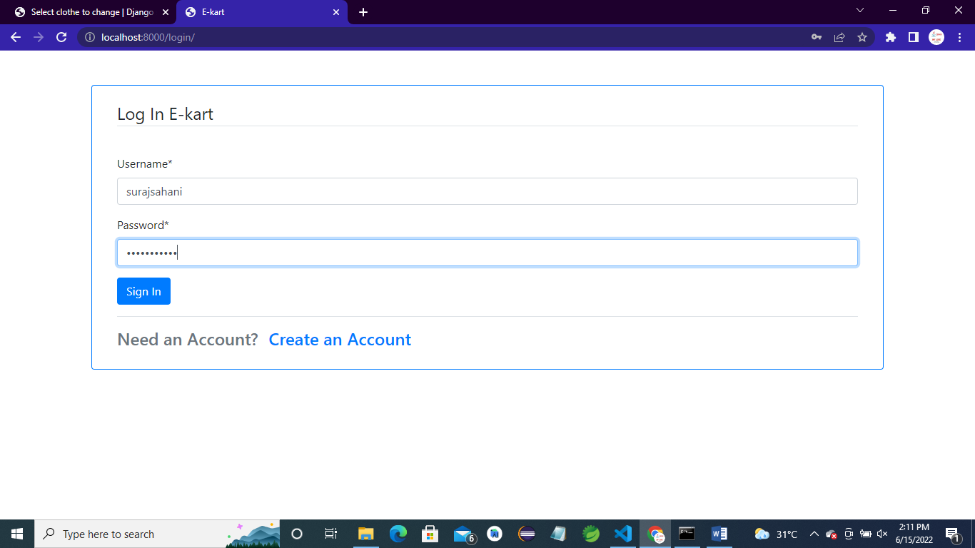

**LAPTOP :-**

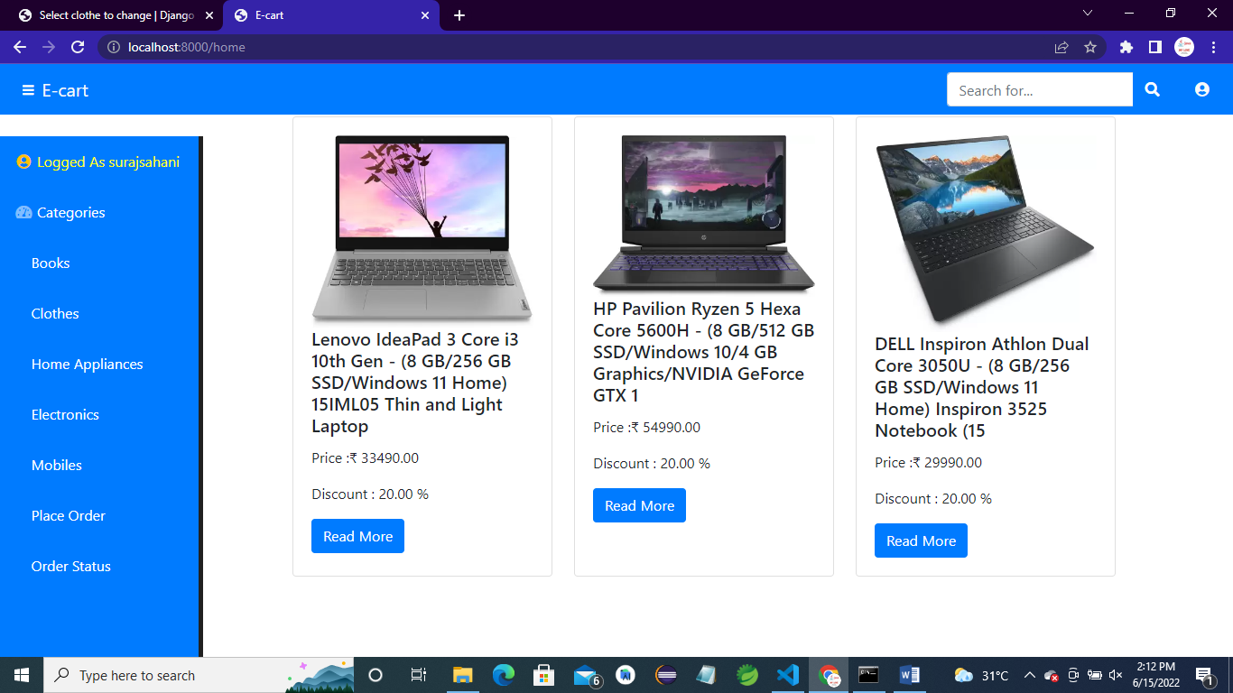

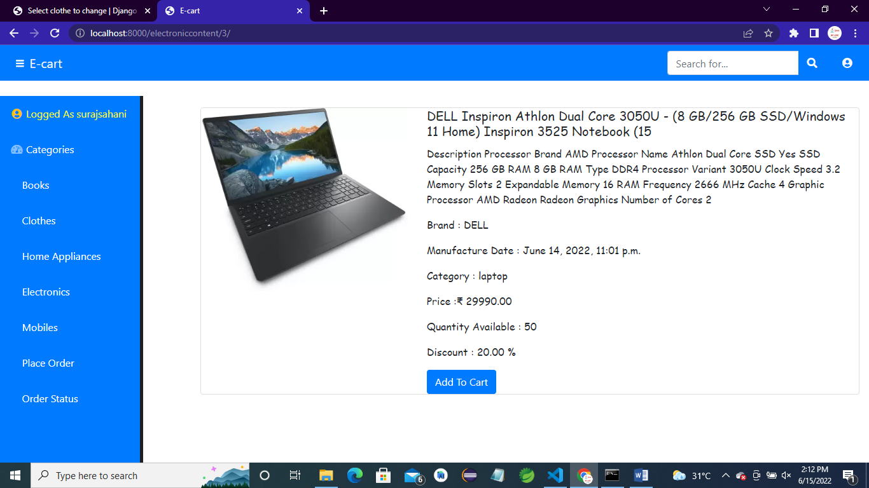

**AFTER USER ADD PRODUCT IN CART THEN THE QUANTITY OF THAT PRODUCT IS DECREASED BY 1.**

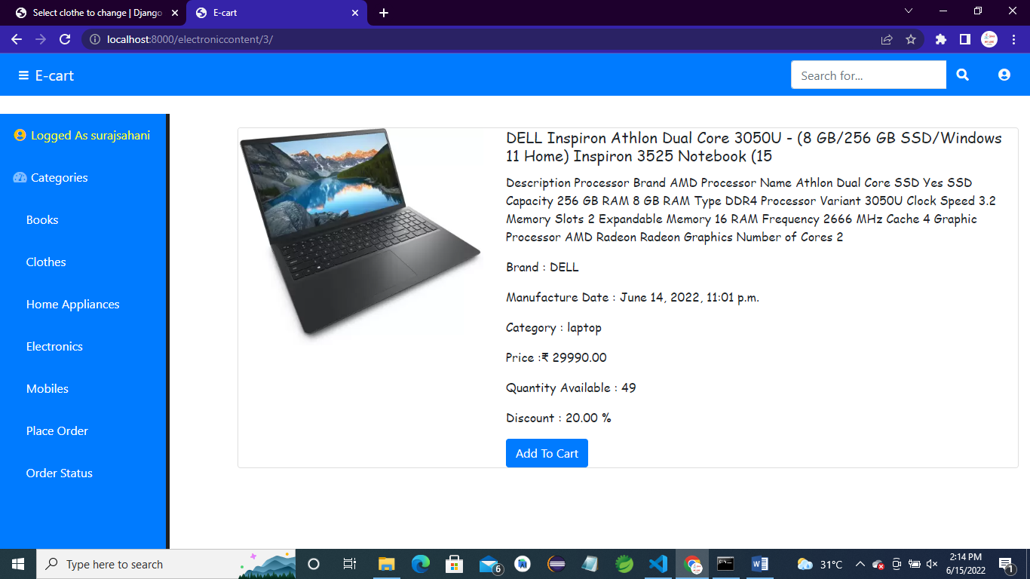

**BOOKS :-**







**CLOTHES :-**

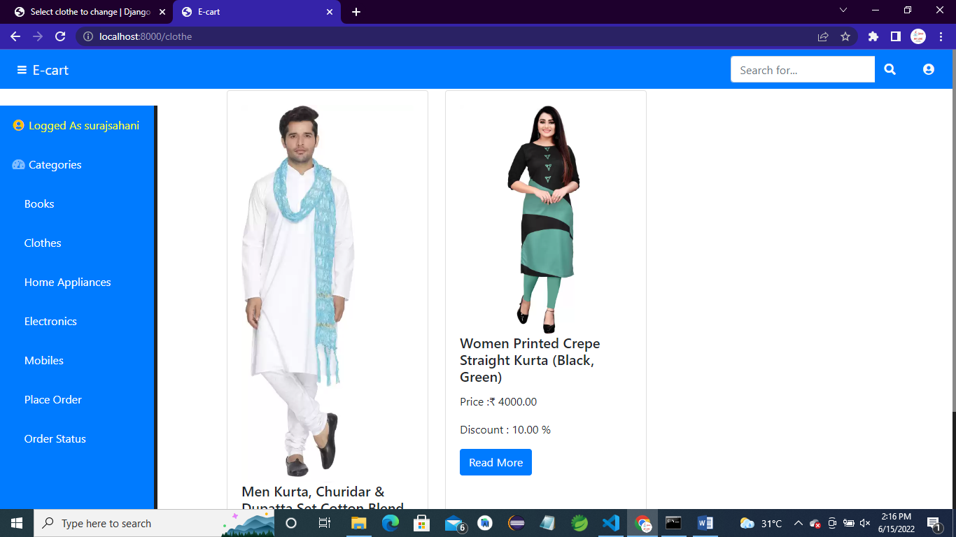

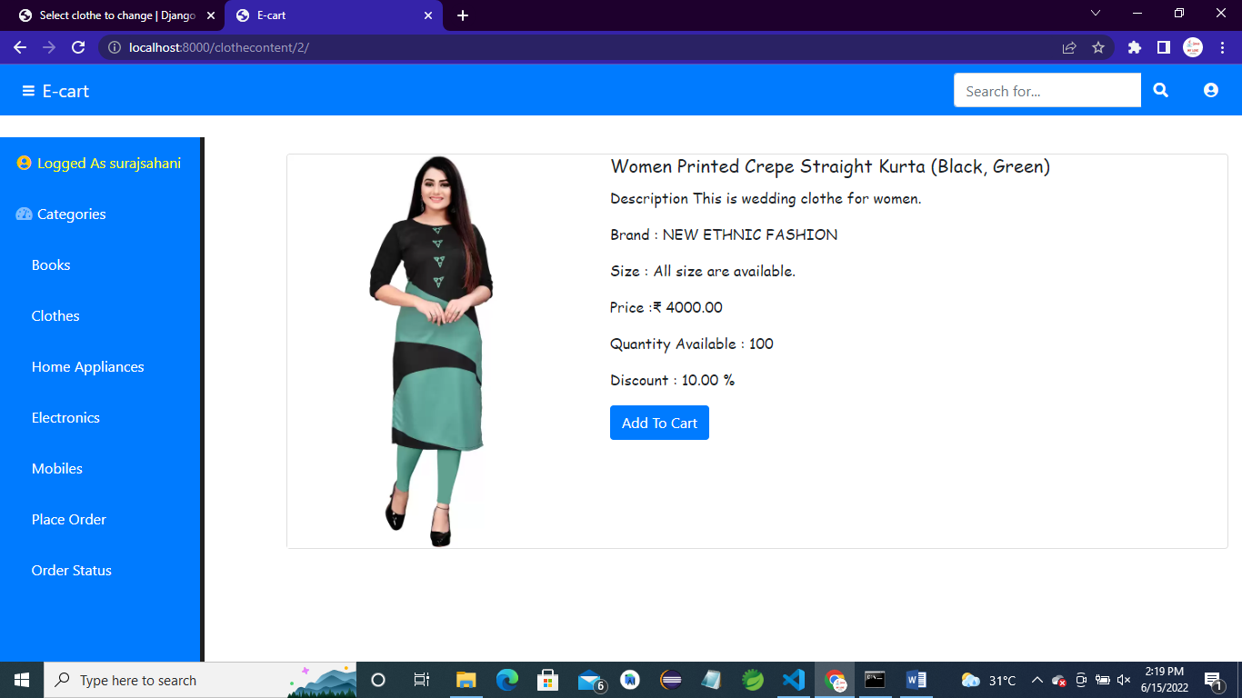

**MOBILES :-**

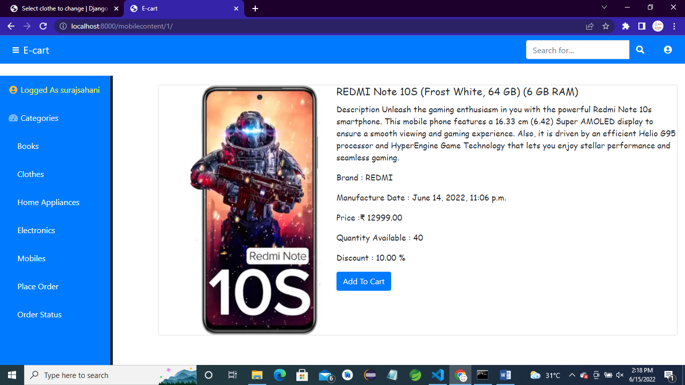

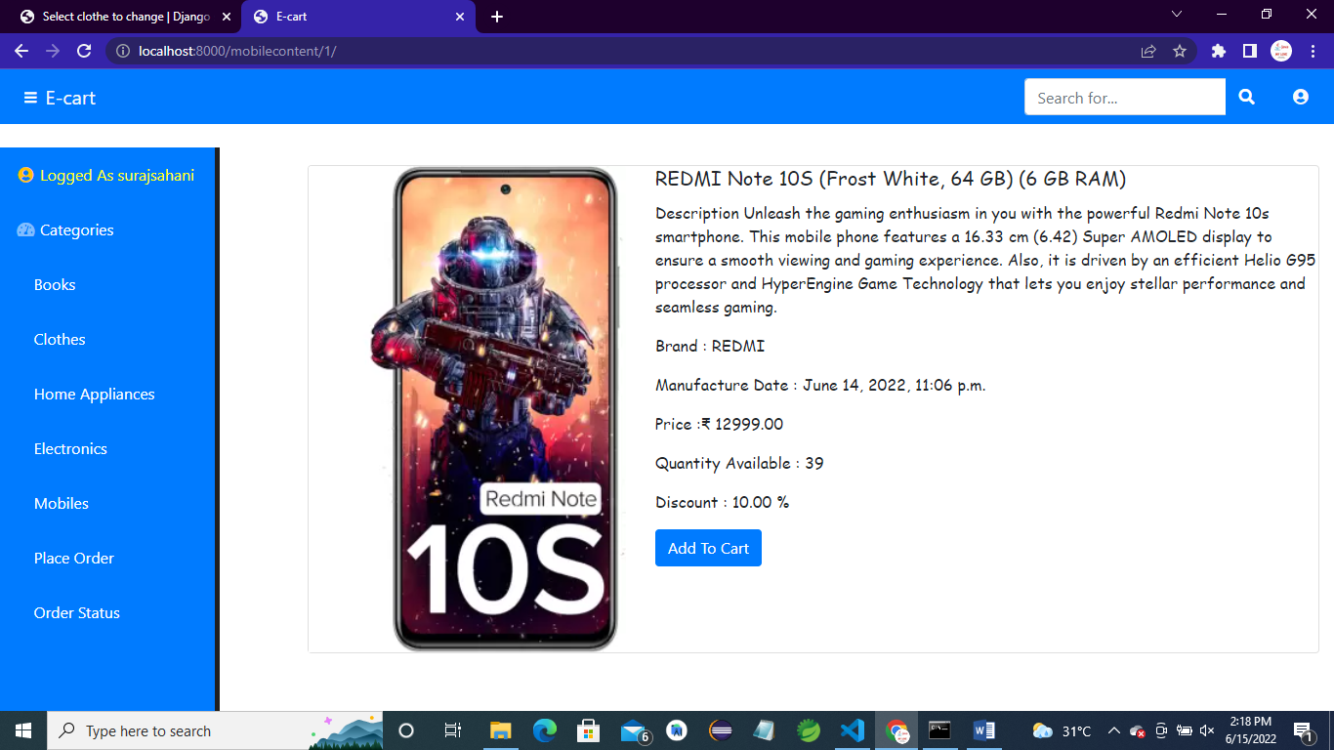

**HOME APPLIANCES :-**

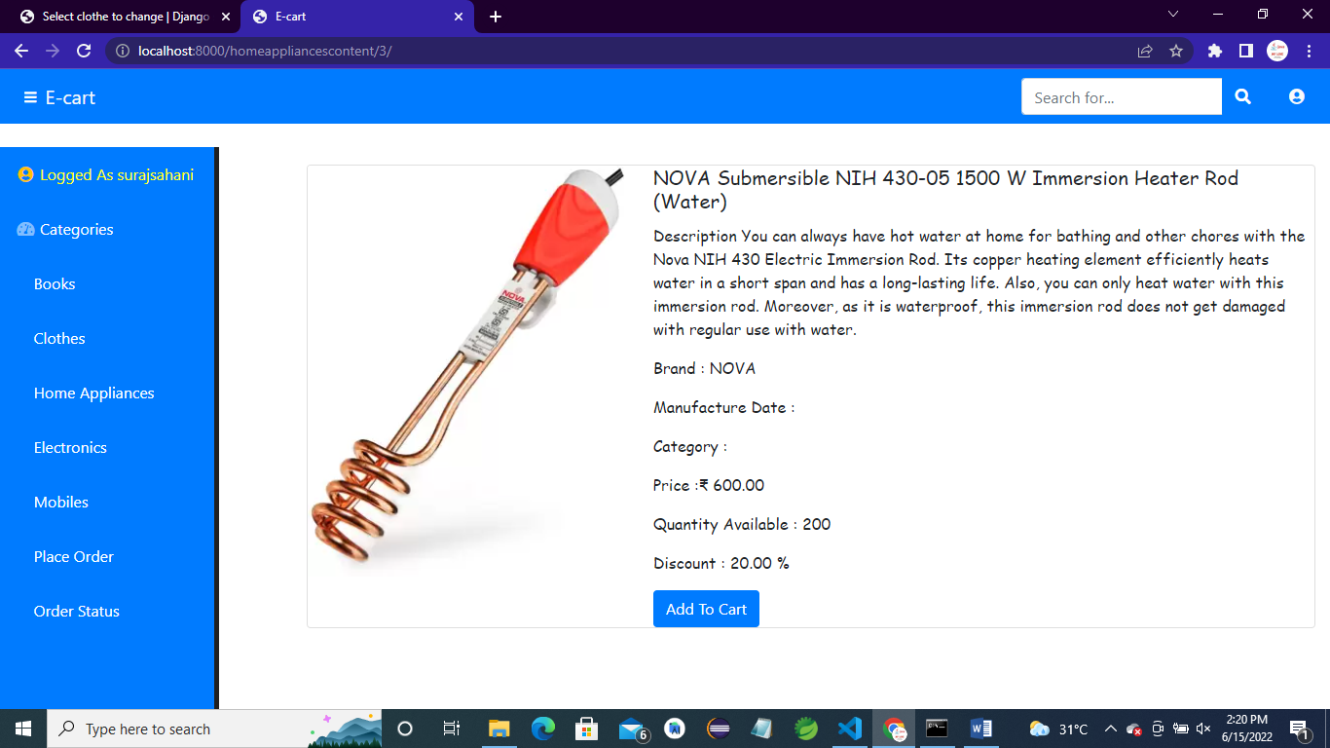

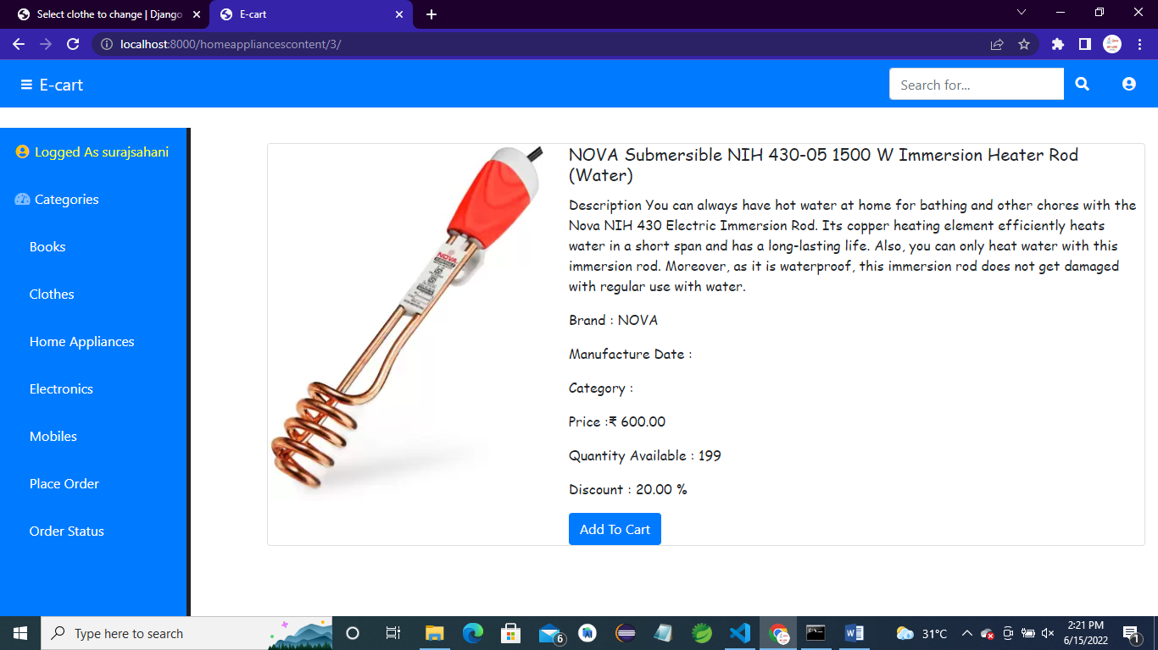

**PLACE ORDER :-**

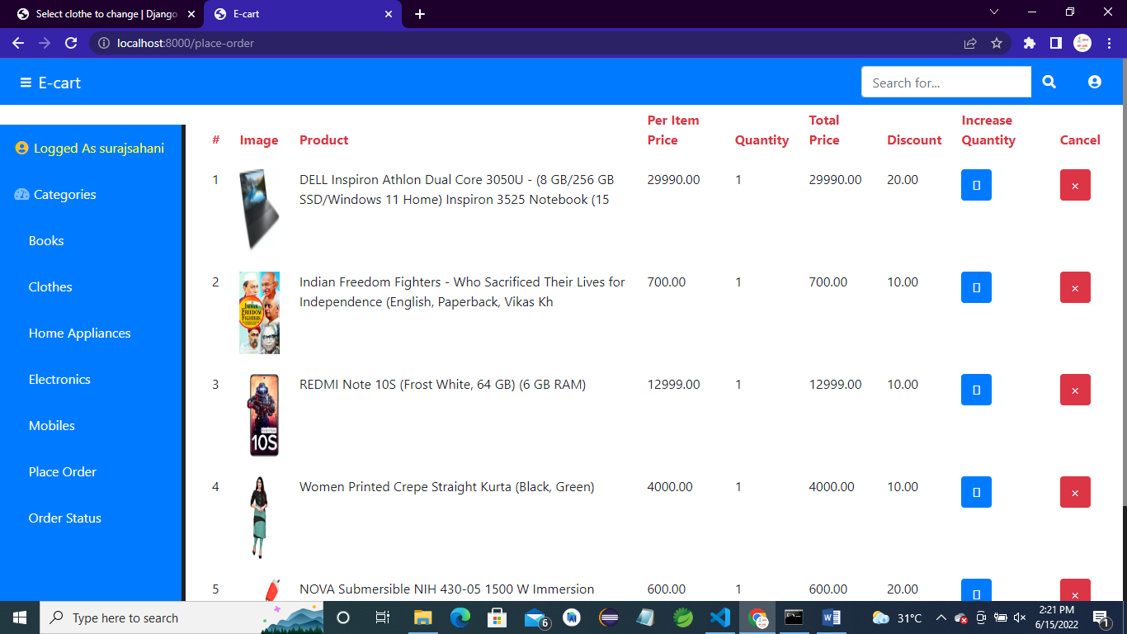

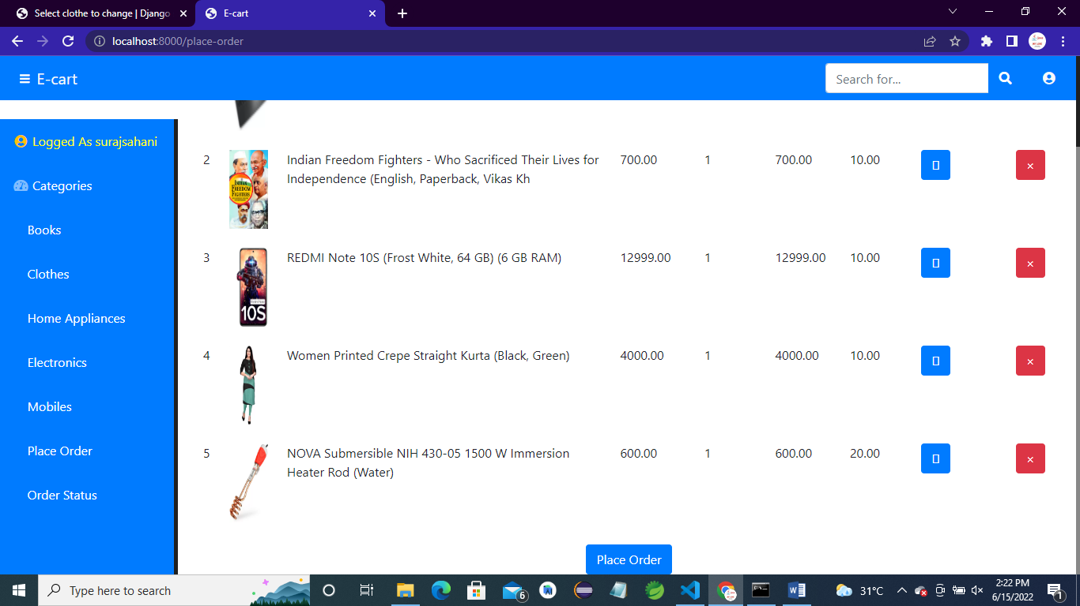

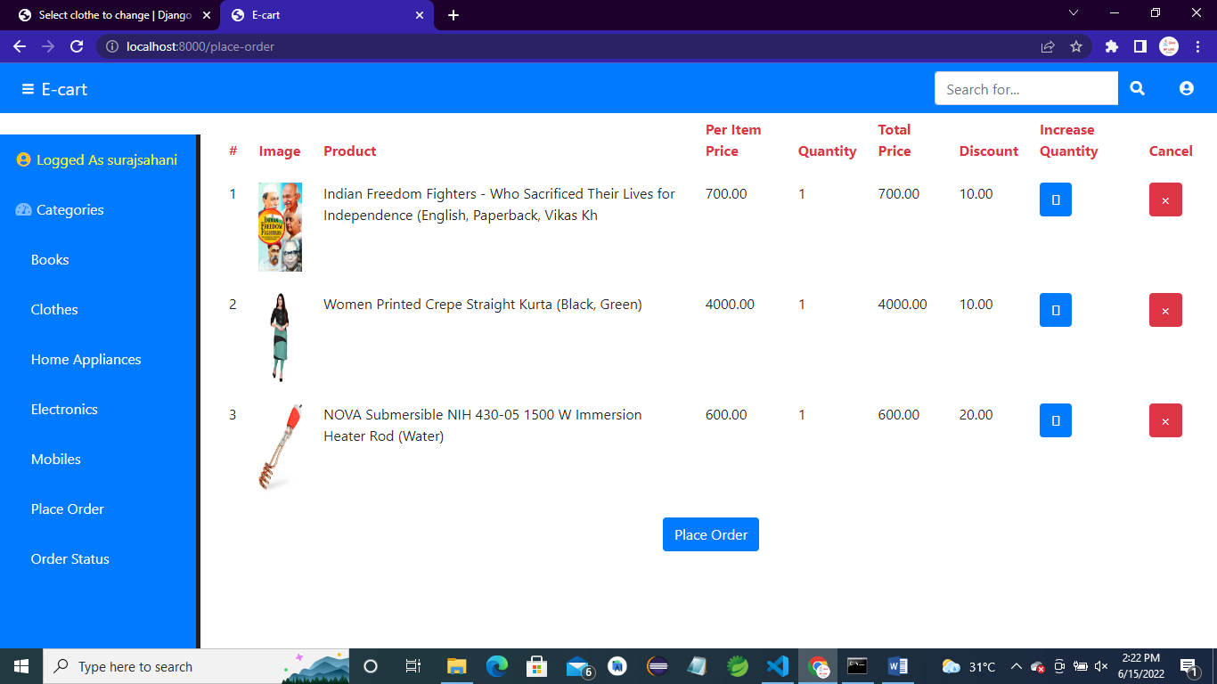

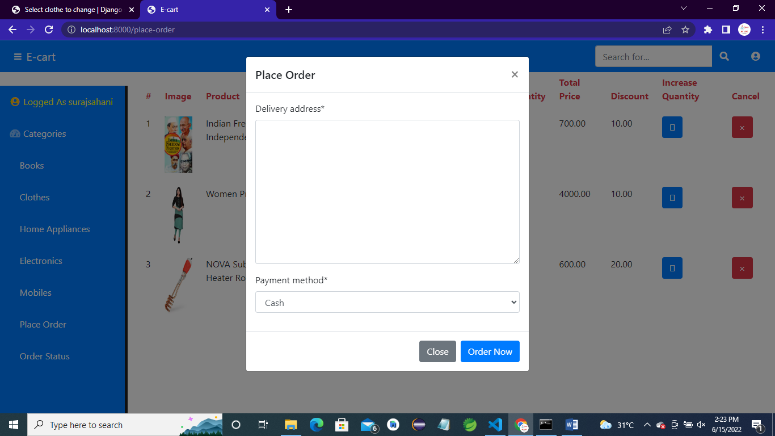

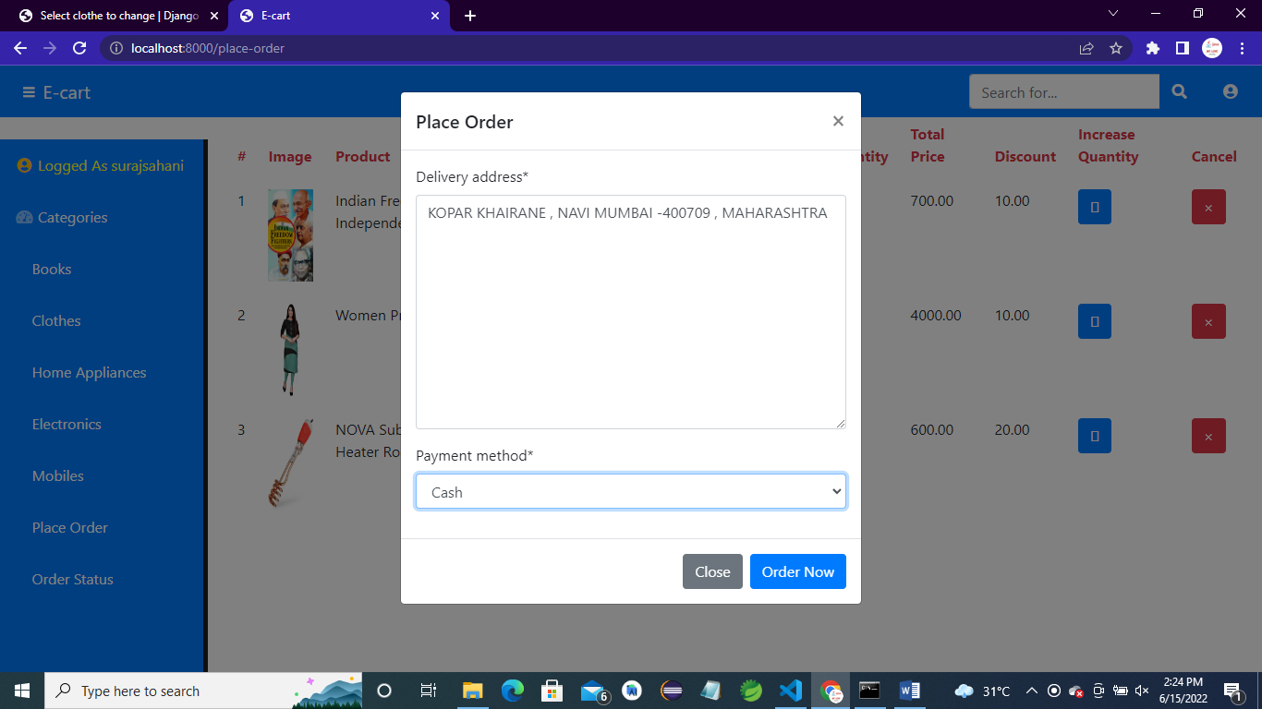

**AFTER ORDER IS PLACED CART WILL BECOME EMPTY.**

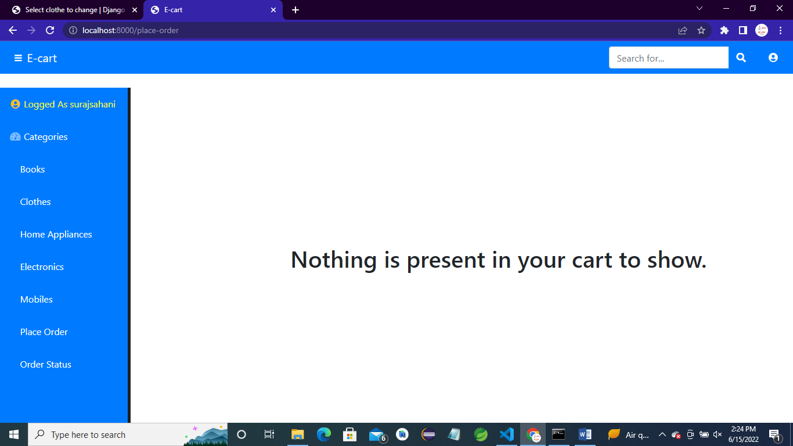

**USER CAN ALSO CANCEL HIS ORDER.**

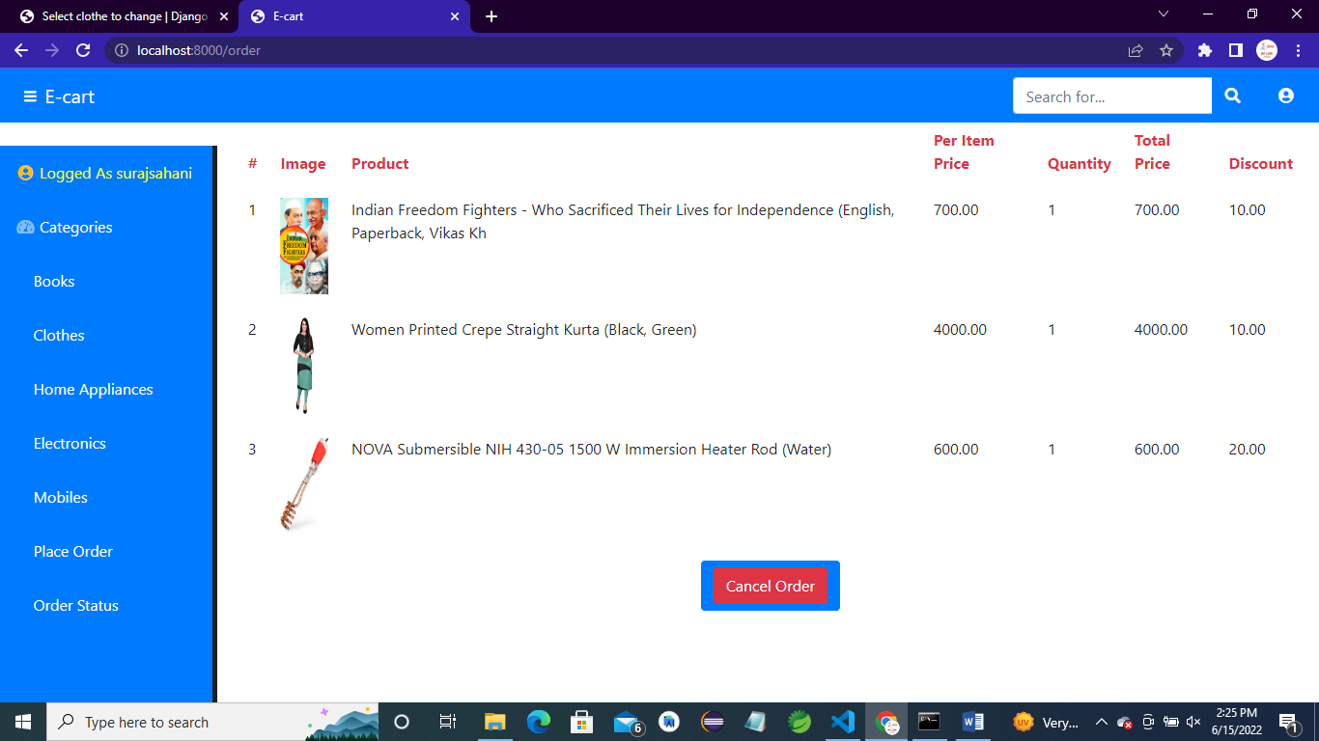

**AFTER SUCCESSFUL ORDER IS CANCELLED USER WILL SEE BELOW MESSAGE.**

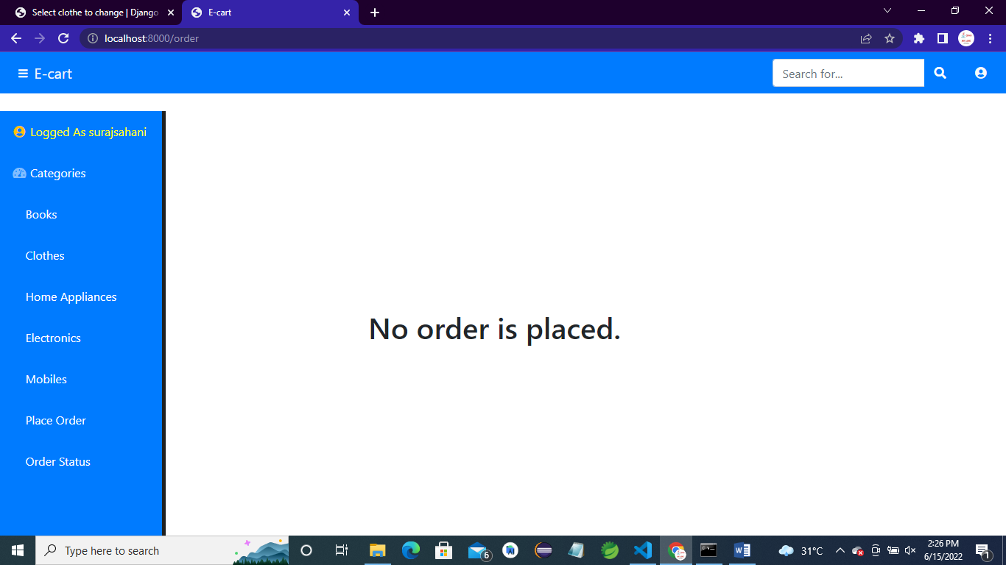

**LOGOUT :-**

